**Senior Design 1**

Variable Length Air Column Resonator with Electronic Excitation

**Concept Description Specification**

Rev1 / 9-12-2020

Fall 2020

Sound Logic

Matt Falconer, Hung Do, and Abdullah Abdulrahman

Professor Paul Watta

**Problem Statement**

|  |  |
| --- | --- |
| **Professional Brass Musicians** | |
| **Advantages** | **Disadvantages** |
| Good Amplitude Control | Expensive to Hire |
| Good Tone Quality | Limited Frequency Range |
|  | Limited Playing Speed |
|  | Limited Sound Power |
|  |  |

|  |  |
| --- | --- |
| **Software Synthesizers** | |
| **Advantages** | **Disadvantages** |
| Low Music Production Costs | Limited Tone Quality |
| Unlimited Frequency Range | Amplitude Control is Time Consuming |
| Unlimited Playing Speed | No Built-In Sound Power Capability |
|  |  |
|  |  |

|  |  |
| --- | --- |
| **Hybrid Hardware/Software Synthesizer** | |
| **Advantages** | **Disadvantages** |
| Low Music Production Costs | Amplitude Control is Time Consuming |
| Large Frequency Range | Electrical Power Consumption |
| High Playing Speeds |  |
| High Sound Power |  |
| Good Tone Quality |  |

**Physics Background: How a brass instrument works (resonator)**

-explain that modeling a brass instrument requires modeling a set of harmonic frequencies

-explain what a synthesizer does

The proposed project concept is a brass instrument synthesizer. Unlike a traditional synthesizer which attempts to recreate the entire frequency output spectrum of an instrument, this synthesizer will create musical tones by synthesizing fundamental frequencies, which are then passed into a physical brass instrument to create musical tones.

Realize the benefits of the real instrument and software instrument in one hybrid system. An important primary objective for this system is to create acoustic input at a sufficient frequency and power level such that the air column within the brass instrument resonates at its intended set of resonance frequencies. Achieving this objective will allow another primary objective to be pursued, which is the ability to resonate the air column at a musically useful set of discrete fundamental frequencies.

Users: Music Producers, Recording Studios, Music Composers.

In order for these objectives to be achieved, the system must perform two critical functions. First, the system must synthesize analog fundamental frequency signals, amplify them, and then input them to the system’s loudspeaker. Additionally, the system must control the length of the brass instrument’s air column synchronously, such that the fundamental frequency being played by the loudspeaker always matches one of the resonant frequencies of the air column.

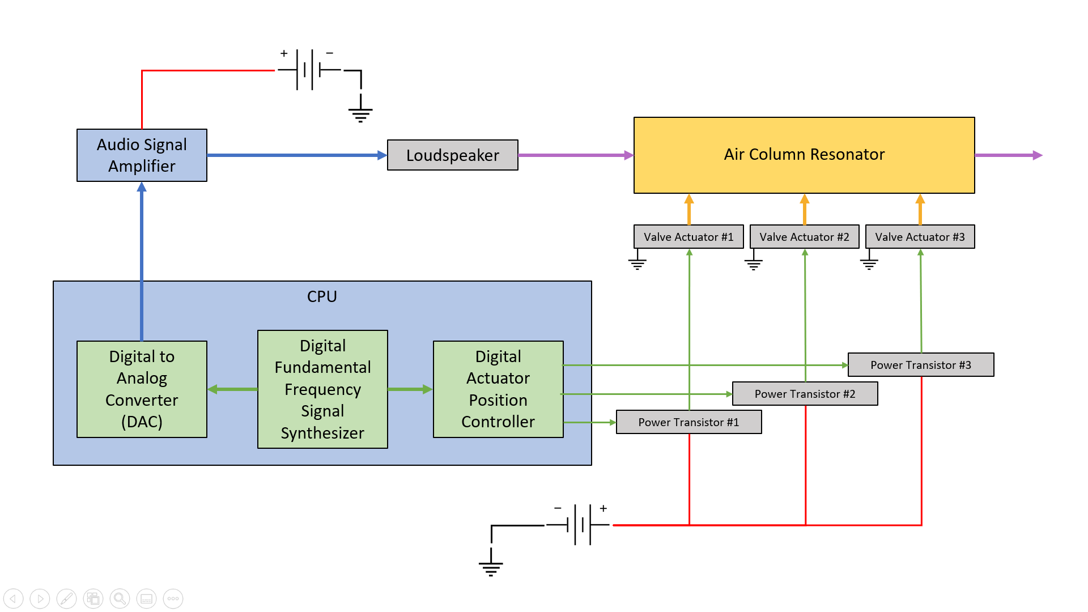

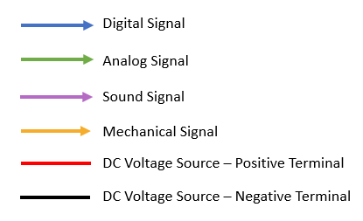

System Modules:

-Control CPU Module (green in diagram) (developed)

-synthesize fundamental frequency signals

-Sound Output Module (blue in diagram) (developed)

-amplify fundamental frequency signals

-input fundamental frequency signals to the resonator

-Valve Actuator Module (gray in diagram) (developed)

-amplify the current of the valve actuator signals

-actuate the instrument’s valves to the desired position

**-**Control CPU Module

-Computer is acquired and then programmed

-DAC is acquired

-Software on the Control CPU is developed

-Sound Output Module

-Audio amplifier is acquired

-Loudspeaker is acquired

-Resonator is acquired

-Loudspeaker mounting hardware is developed

-frequency output simulate

Valve Actuator Module

-power transistors are acquired

-valve actuators are acquired

-valve control software is developed

**1. SYSTEM DESCRIPTION**

•Provide holistic description of the system

•Define primary system objectives (what problem will the system address)

•Idenfity who will be the users

•Identify the primary functions will be performed to fulfill the objectives

•Associate modules with system level performance – preliminary and notional

•Identify generic hardware/software components of each module – preliminary and notional

•Identify generic data, signal, and power interfaces between modules

•Indicate which modules will be acquired, simulated, or developed.

Notional System Diagram and Modular Decomposition

* Identify major modules and describe their functions. Include generic hardware and software components and software modules if applicable. Do not identify specific items (e.g. model number, vendor).
* **Figure:** system block diagram showing major modules/components and interconnections. Indicate power connections, signal input/output, data input/outputs.

**1.1 System Background:**

* Identify multidisciplinary aspects of the overall system (e.g. mechanical. electrical, computer, software)
* Identify areas of ethical responsibility for the development team if this project if it were fielded
* Identify any contemporary (present day) issues that are affected if this project if it were fielded

**1.2 Environmental Constraints:**

**(Limited Importance)**

*Describe operating environment for actual fielded system.*

*temperature range:*

*shock, vibration*

*rain and moisture*

*note: the system you build will likely be a limited prototype that does not have to meet environmental contstraints.*

**1.3 References**

* list standards, technical documentation, reports, publications that are relevant to the project.

**2. DELIVERABLES**

**2.1 Deliverable System**

Describe the actual system you are going t build.

*e.g. bench prototype, full scale prototype, ….*

**3. Risk Management**

**3.1 Identified Risks**

* List and number any unknown factors that could cause the project to fail. This includes lack of knowledge of certain aspects or components, availability of components, etc.
* List any safety related factors
* Assess the likelihood of each factor occurring
* Asses the severity if of that factor occurring

**3.1 Risk Mitigation Steps**

* list steps taken to reduce and warning or alter risks
* describe status of identified risks and effectiveness of current risk mitigation steps
* describe any further steps that need to be taken

red = alert

yellow = warning

green = caution

|  |  |  |  |  |  |  |  |  |  |  |  |  |  |  |
| --- | --- | --- | --- | --- | --- | --- | --- | --- | --- | --- | --- | --- | --- | --- |
| death/serious injury | | **Penalty of Occurrence** | 10 | |  |  |  |  |  |  |  |  |  |  |
| injury, serious property damage | | 9 | |  |  |  |  |  |  |  |  |  |  |
| collateral property damage | | 8 | |  |  |  |  |  |  |  |  |  |  |
| system loss | | 7 | |  |  |  |  |  | 2 |  |  |  |  |
| system damage | | 6 | |  |  |  |  |  |  |  |  |  |  |
| component loss | | 5 | |  |  |  |  |  |  |  |  |  |  |
| component damage | | 4 | |  |  |  |  |  | 3 |  |  |  |  |
| serious project delay | | 3 | |  |  |  |  |  |  |  |  |  |  |
| project delay | | 2 | |  | 1 |  |  |  |  |  |  |  |  |
|  |  | 1 | |  |  |  |  |  |  |  |  |  |  |
|  |  |  | | 1 | 2 | 3 | 4 | 5 | 6 | 7 | 8 | 9 | 10 |
|  |  | **Risk of Occurrence** | | | | | | | | | | | |
|  |  |  | very unlikely | | | | |  |  |  | very likely | | |
| **table 3.1: risk assessment** <date> | | | | | | | | | | | | | |

|  |  |  |  |  |  |  |  |
| --- | --- | --- | --- | --- | --- | --- | --- |
|  |  |  |  |  |  |  |  |
|  | | | | | | | |

**4. Budget and Status**

**Cost Estimate** <version number, project phase , date>

|  |  |  |  |  |  |  |  |
| --- | --- | --- | --- | --- | --- | --- | --- |
| **module** | **no** | **Item** | **Vendor** | **Model/Part No.** | **Unti Cost** | **Qty** | **Sub Total  Cost** |
|  |  |  |  |  |  |  |  |
|  |  |  |  |  |  |  |  |
|  |  |  |  |  |  |  |  |
|  |  |  |  |  |  |  |  |
|  |  |  |  |  |  |  |  |
|  |  |  |  |  |  |  |  |
|  |  |  |  |  |  |  |  |
|  |  |  |  |  |  |  |  |
|  |  |  |  |  |  |  |  |
|  |  |  |  |  |  |  |  |
|  |  |  |  |  |  |  |  |
|  |  |  |  |  |  |  |  |
|  |  |  |  |  |  |  |  |
|  |  |  |  |  |  |  |  |
| **Total Cost Estimates** |  |  |  |  |  |  |  |

**(Rough Order of Magnitude = ROM)**

**Component Status** <version number, project phase , date>

|  |  |  |  |  |
| --- | --- | --- | --- | --- |
| **module** | **no** | **Comments** | **Status** | **Availability date** |
|  |  |  |  |  |
|  |  |  |  |  |
|  |  |  |  |  |
|  |  |  |  |  |
|  |  |  |  |  |
|  |  |  |  |  |
|  |  |  |  |  |
|  |  |  |  |  |
|  |  |  |  |  |
|  |  |  |  |  |
|  |  |  |  |  |
|  |  |  |  |  |
|  |  |  |  |  |
|  |  |  |  |  |

Status:

REQ – requested

APP – approved

ORD– ordered

TBD – to be determined

**5. Project Schedule**<version number, project phase , date>

**Master Schedule**<version number, project phase , date>



**Other Scheduled items** (components acquisition, assemblies due, excursion due)